TRYHACKME LAB REPORT

Windows Fundamentals 2
Internship: DG Interns HUB — Week 2
Platform: TryHackMe
Room: Windows Fundamentals 2
Domain: Windows Internals and Cybersecurity
Tools: Windows Registry and System Utilities

1. Aim
To understand Windows system configuration, the Windows Registry, administrative utilities and other built-in tools used for system management and security investigations.

2. Objectives
- Understand Windows system configuration tools.
- Learn the purpose and structure of the Windows Registry.
- Identify important administrative utilities.
- Understand environment variables.
- Learn how Windows tools support troubleshooting and security investigations.

3. Introduction
Windows provides built-in utilities for managing system settings, applications, services and configuration information.
Cybersecurity professionals use these utilities to examine system behaviour, investigate configuration changes and identify settings that may be relevant to an incident.

4. Important Concepts

4.1 System Configuration
System Configuration is a Windows utility used to review certain startup and system configuration options.
It can help administrators troubleshoot startup problems and examine selected configuration settings.

4.2 Windows Registry
The Windows Registry is a hierarchical database that stores configuration information for Windows, applications and users.
Important Registry root keys:
Registry Key | Purpose
HKEY_LOCAL_MACHINE (HKLM) | System-wide configuration
HKEY_CURRENT_USER (HKCU) | Configuration for the current user
HKEY_USERS (HKU) | Settings for loaded user profiles
HKEY_CLASSES_ROOT (HKCR) | File associations and related class information
HKEY_CURRENT_CONFIG (HKCC) | Current hardware profile information
Security relevance: Unexpected Registry changes can sometimes indicate unauthorized configuration changes or persistence mechanisms. Analysts should verify the context and correlate findings with other evidence.

4.3 Computer Management
Computer Management provides access to administrative tools for managing a Windows computer.
Depending on permissions and configuration, it can provide access to:
- Event Viewer.
- Device Manager.
- Shared Folders.
- Local Users and Groups.
- Disk Management.
- Services and applications.

4.4 Environment Variables
Environment variables store values used by applications and system processes.
Examples:
- PATH — directories searched for executable commands.
- TEMP — temporary-file location.
- USERPROFILE — the current user's profile directory.
- WINDIR — the Windows installation directory.
An analyst may inspect environment variables when investigating unexpected application behaviour or execution paths.

4.5 System Information
System information tools provide details about hardware, operating system versions and system configuration.
These details help analysts understand the environment being investigated and identify relevant configuration differences.

5. Practical Methodology
- Sign in to TryHackMe.
- Open the Windows Fundamentals 2 room.
- Start the required lab machine if the room requests it.
- Read each task carefully.
- Explore the system utilities covered by the room.
- Record the answers from your actual observations.
- Capture screenshots of important steps and completed tasks.

6. Results and Findings
Complete the following table using your lab results.
Item | Actual Observation
System utility examined | [Enter utility name]
Registry concept learned | [Enter observation]
Registry key examined | [Enter key, if applicable]
Environment variable examined | [Enter variable]
Important security observation | [Enter your finding]

7. Security Relevance
Windows system utilities help analysts investigate configuration changes and unexpected system behaviour.
Examples of relevant investigations include:
- Unexpected changes to startup configuration.
- Unauthorized Registry modifications.
- Suspicious executable paths.
- Unapproved administrative changes.
- Unexpected system utilities or services.
These observations require verification and should not automatically be treated as proof of compromise.

8. Challenges and Limitations
- Some utilities require administrator privileges.
- Windows versions may have different interfaces.
- Registry changes can affect system stability.
- Findings must be interpreted using the system's configuration and available evidence.

9. Learning Outcomes
- Understand the purpose of Windows system utilities.
- Explain the structure of the Windows Registry.
- Identify important Registry root keys.
- Understand environment variables.
- Recognize configuration changes relevant to security investigations.
- Document technical findings clearly.

10. Evidence Checklist
- Screenshot of the TryHackMe room.
- Screenshots of relevant system utilities.
- Actual task answers recorded.
- Registry or configuration observations documented.
- Evidence saved in the Week 2 Findings folder.
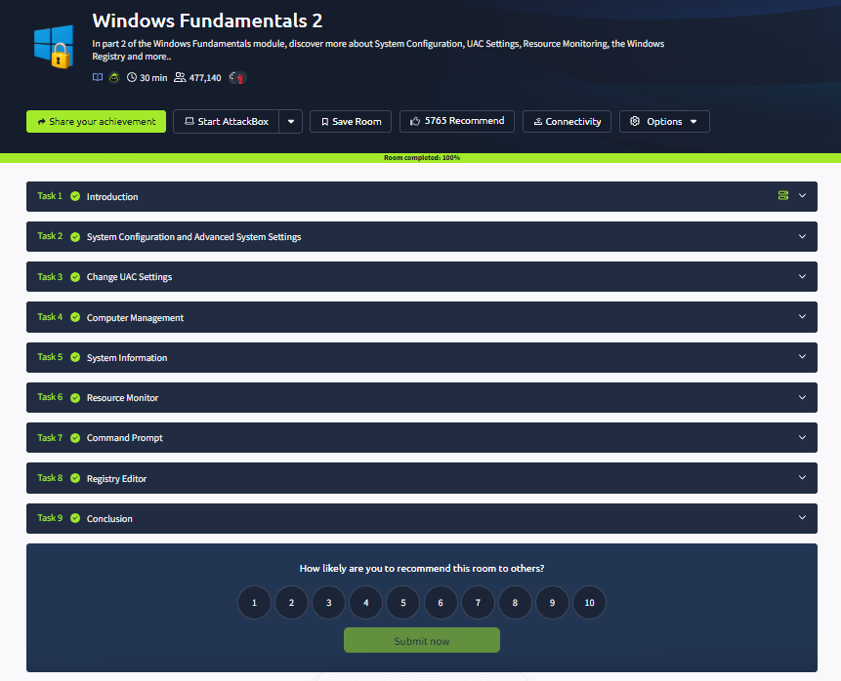

11. Conclusion
The Windows Fundamentals 2 lab develops knowledge of Windows configuration utilities, Registry structure and environment variables. These concepts help security analysts understand system configuration and investigate suspicious changes during incident response.

